WEEK - 1
EXPERIMENT-1
1.AIM: To find the roots of a quadratic equation using C++.
Description:

To develop a C++ program that finds the roots of a quadratic equation of the form:
ax² + bx + c = 0
The program begins by prompting the user to input the coefficients a, b, and c. It then calculates the discriminant (D = b² - 4ac) to determine the nature of the roots:
If D > 0, the equation has two real and distinct roots.
If D == 0, the equation has two real and equal roots.
If D < 0, the equation has two complex (imaginary) roots.

Procedure or Algorithm:
Depending on the value of the discriminant, the program uses the appropriate formula to compute and display the roots. It also provides meaningful messages to indicate the nature of the roots to the user. Use of conditional statements, mathematical functions, and input/output operations in C++ to develop the program.

Program:
#include<iostream>
#include<cmath>
using namespace std;
int main()
{
float a,b,c;
cout<<"enter coefficiants a,b,c";
cin>>a>>b>>c;

float discriminant = b*b-4*a*c;
float root1,root2;

if(a==0){
cout<<"This is not a quadratic equation"<<endl;
}
else if(discriminant>0){
root1=(-b+sqrt(discriminant))/(2*a);
root2=(-b-sqrt(discriminant))/(2*a);
cout<<"Root1 ="<<root1<<endl;
cout<<"Root2 ="<<root2<<endl;
}
else if(discriminant==0){
root1=root2=-b/(2*a);
cout<<"Root ="<<root1<<endl;
}
else{
float realpart = -b/(2*a);
float imgpart = sqrt(-discriminant)/(2*a);
cout<<"root1="<<realpart<<"+"<<imgpart<<"i"<<endl;
cout<<"root2="<<realpart<<"-"<<imgpart<<"i"<<endl;
}
return 0;

}

Output:

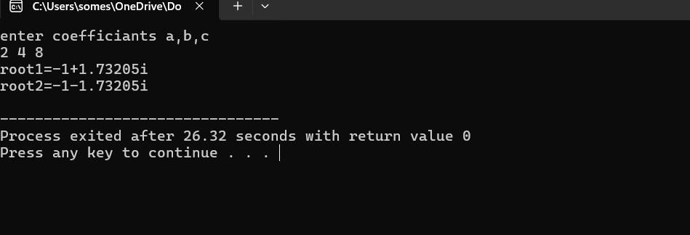

EXPERIMENT-2
2.AIM: Find factorial of a given number using recursion

Description:

The factorial of a non-negative integer nnn is the product of all positive integers less than or equal to nnn. It is denoted by n!n!n!. Mathematically,
n!=n×(n−1)×(n−2)×⋯×2×1n! = n \times (n-1) \times (n-2) \times \dots \times 2 \times 1n!=n×(n−1)×(n−2)×⋯×2×1
By definition,
0!=10! = 10!=1
In recursion, a function calls itself to solve a smaller version of the same problem until it reaches a base case. The recursive definition of factorial is:
Base Case: If n=0n = 0n=0 or n=1n = 1n=1, return 1.
Recursive Case: If n>1n > 1n>1, return n×factorial(n−1)n \times \text{factorial}(n-1)n×factorial(n−1).
Algorithm :
The algorithm for finding the factorial of a number using recursion begins by checking if the input number nnn is 0 or 1. If it is, the algorithm immediately returns 1, as this is the base case. If nnn is greater than 1, the algorithm makes a recursive call to itself with the argument n−1n-1n−1. The value returned from this recursive call is then multiplied by nnn to obtain the factorial. This recursive process continues, reducing the value of nnn by 1 at each step, until the base case is reached. Once the base case returns 1, the results from each call are multiplied together, producing the factorial of the original number.

Program:
#include<iostream>
using namespace std;
long factorial(int n){
if(n==0 || n==1){
return 1;
}
else{
return n*factorial(n-1);
}
}
int main(){
int number;
cout<<"Enter positive number"<<endl;
cin>>number;
if(number<0){
cout<<"factorial cannot be found for negative numbers"<<endl;
}
else{
long result = factorial(number);
cout<<"Factorial of "<<number<<" is = "<<result ;
}
return 0;
}

Output:

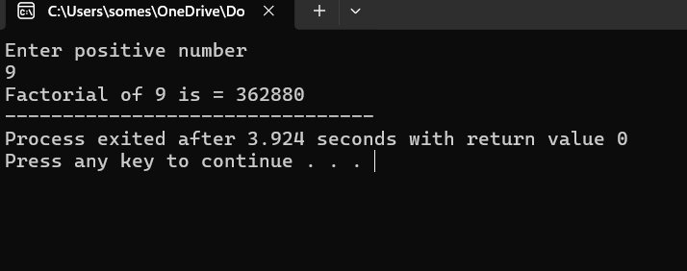

EXPERIMENT-3
3.AIM: Implement scope resolution and namespaces.
Description:
In C++, variables and functions can exist in different scopes such as local, global, or within a class. The scope resolution operator (::) is used to access a global variable when a local variable has the same name or to define a function outside its class. A namespace groups related identifiers under a single name to avoid naming conflicts. Members of a namespace are accessed using the scope resolution operator or the using directive.
Algorithm:
Define variables or functions in different scopes or inside a namespace. Use the scope resolution operator to access global variables or namespace members explicitly (e.g., namespace_name::member). Optionally, apply the using namespace directive to access members without qualifying them. This prevents ambiguity and organizes code effectively.
Program :

#include<iostream>
using namespace std;
int x = 100;
namespace mynamespace{
int value = 50;
void show(){
cout<<"Inside my namespace, value = "<<value<<endl;
}
}
int main(){
int x=50;
cout<<"local x ="<<x<<endl;
cout<<"global x = "<<::x<<endl;
cout<<"Namespace value ="<<mynamespace::value<<endl;
mynamespace::show();
return 0;
}
Output:

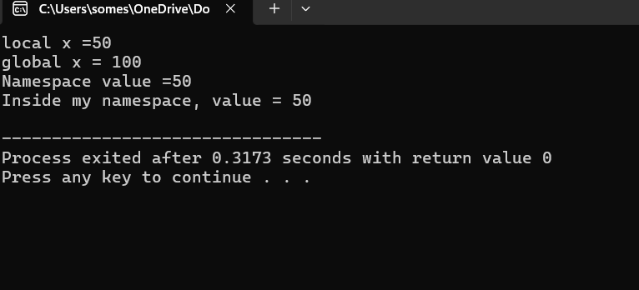

EXPERIMENT-4
4.AIM: Illustrate the use of default arguments and access specifiers
Description:
In C++, default arguments allow functions to have parameters with predefined values, so if a value is not passed during a call, the default value is used. This reduces function overloading and improves flexibility. Default arguments must be given from right to left in the parameter list.
Access specifiers define how class members are accessed:
public: Accessible from anywhere.
private: Accessible only within the class.
protected: Accessible within the class and its derived classes.
These features improve code readability, reusability, and security.
Algorithm:
Declare a function with one or more parameters having default values. When calling the function, omit arguments where defaults should be applied.
Create a class and declare variables and functions under different access specifiers (public, private, protected). Access the members according to their access level, using objects or derived classes. This demonstrates how default arguments simplify function calls and how access specifiers control member accessibility.

Program :

#include <iostream>
using namespace std;
void displayMessage(string name, string greeting = "Hello", int year = 2025) {
cout << greeting << ", " << name << "! Welcome to year " << year << "." << endl;
}
class Person {
public:
string name;
protected:
int age;
private:
string secret;
public:
Person(string n, int a, string s) {
name = n;
age = a;
secret = s;
}
void revealSecret() {
cout << "Secret: " << secret << endl;
}
};

int main(){
displayMessage("somesh");
displayMessage("Rahul", "Hi");
displayMessage("Arjun", "Good Morning", 2030);
Person p1("Akira", 20, "Loves C++");
cout << "Name: " << p1.name << endl;
p1.revealSecret();
return 0;
}

Output :

